People and safety
Sustainability Report 2026 – Chapter 4 (draft)
Julia Hoffmann · 22 September 2026

Safety
Around 1.4 million hours were worked on our sites between January and August 2026 – about a third more than a year earlier, because of the Harrow Bay construction. We recorded one lost-time injury (a contractor's hand injury at the Port of Eastholm) and two recordable injuries. [YTD]
The most serious event was a near miss: on 3 June 2026 a tool fell from height on the MV Sea Atlas (HSE-INC-2026-018). Nobody was injured. As a result, all tools used at height offshore are now tethered, and drop zones are enforced on deck. We held a Safety Stand-Down across all sites on 10 June.
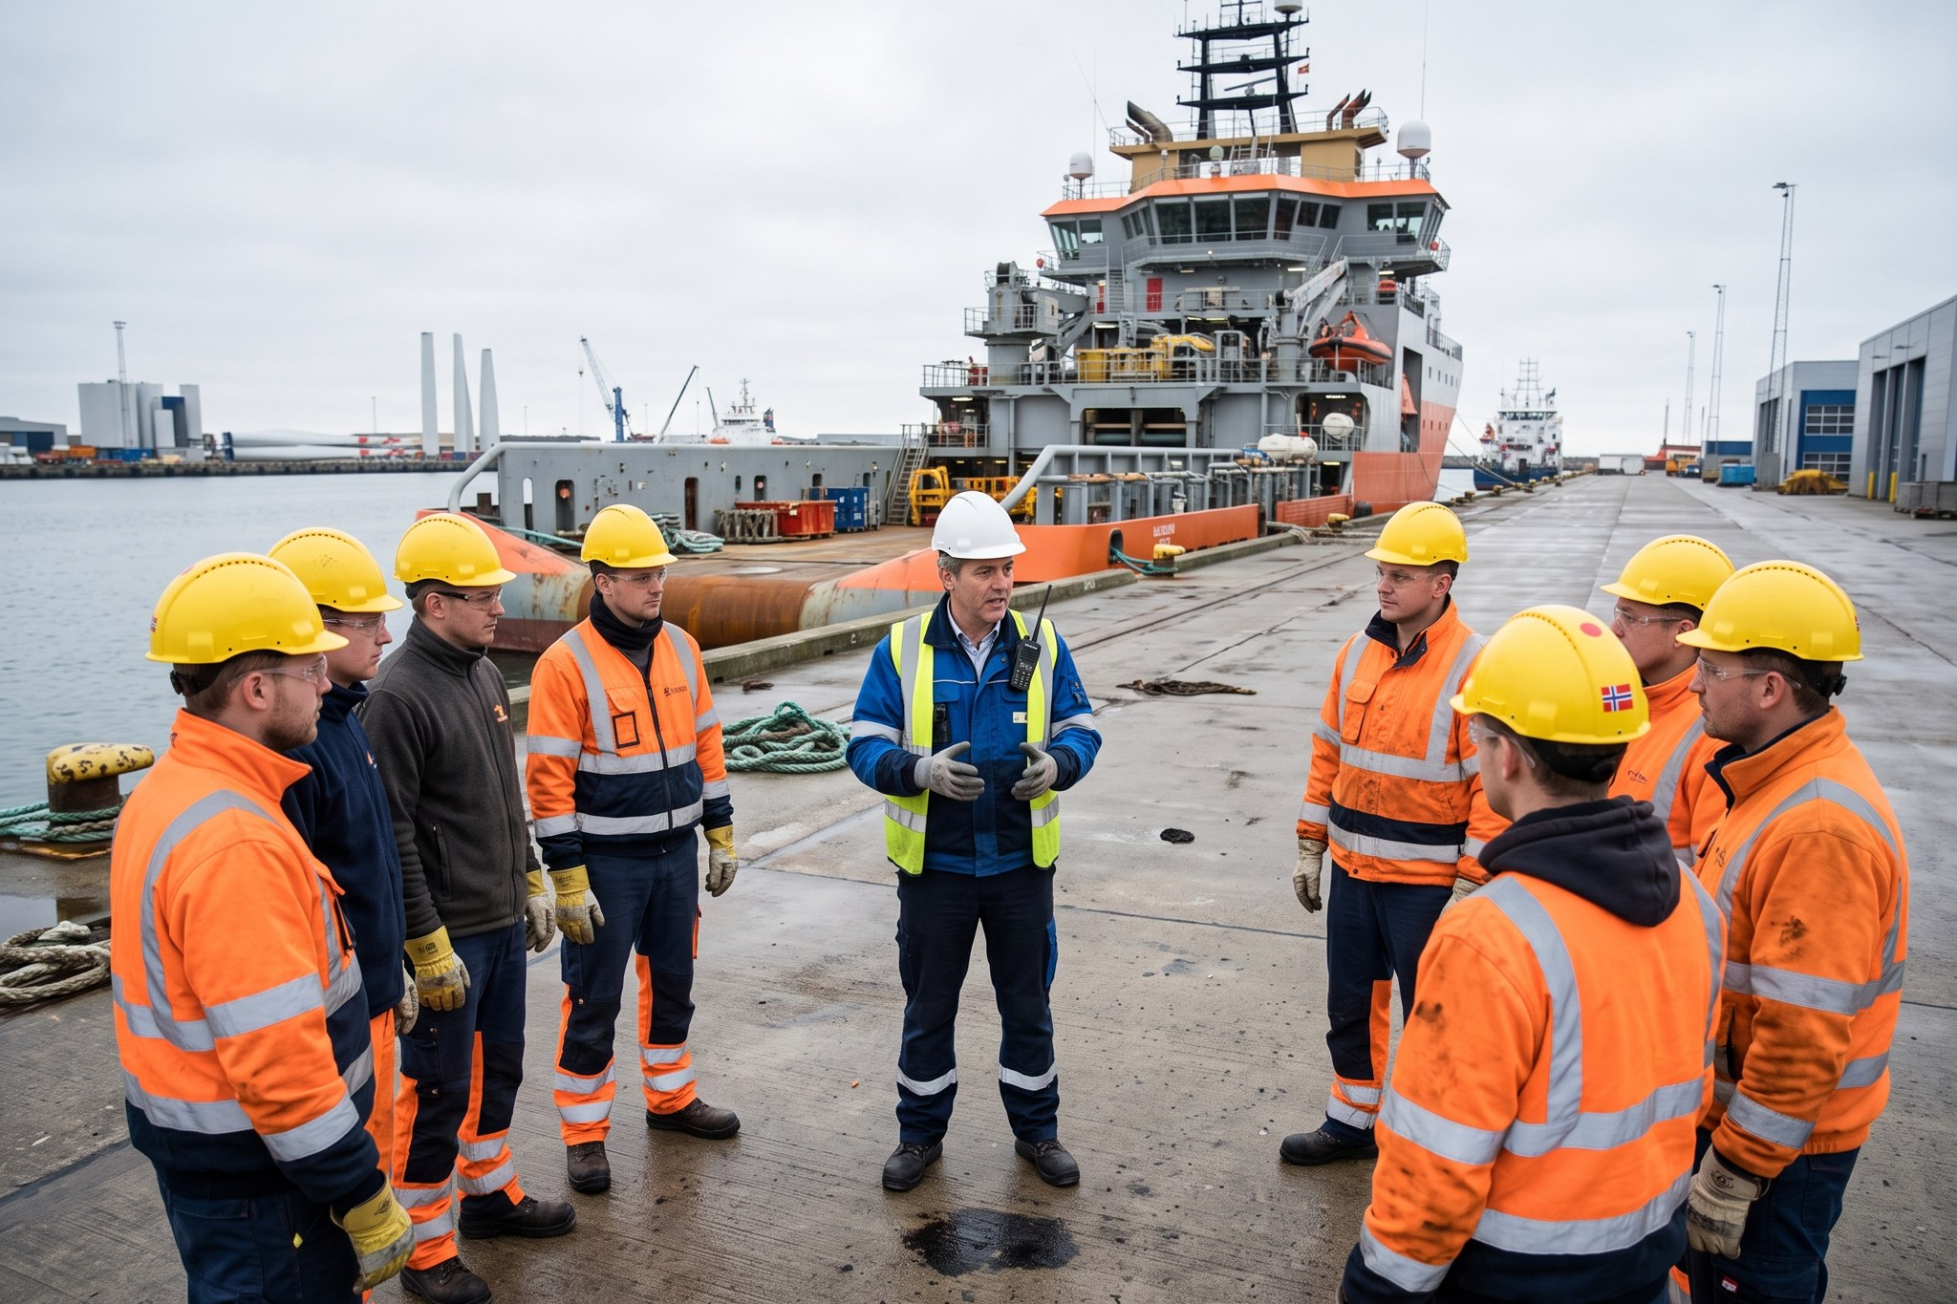
Morning toolbox talk at the Port of Eastholm.

Our people
KPI | 31 Aug 2026
Employees | 450
Women | 34 %
Women in leadership (heads of department) | 31 %
New hires (Jan–Aug) | 64
Training hours per FTE (YTD) | 19.8
Apprentices | 9

The Powering the North campaign helped us to hire 64 people by the end of August. Nine apprentices are training as wind technicians at Kestrel Ridge and in our Hamburg workshop.
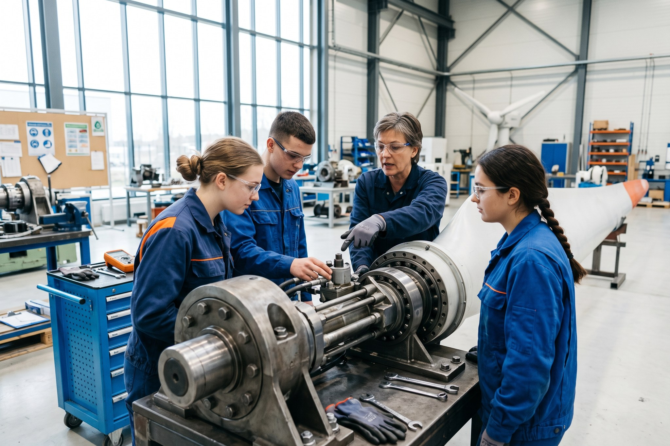
Apprentices in training.

